**Customer Module Work Flow:**

**Landing Page for All User:**

This will be then first page that we render when the user visits the website. From this page, based on the Role, the user clicks on the specific Portal button. In real-time, we may have different applications for different portal. However, in our project, we will create a single project to manage all the Portals.

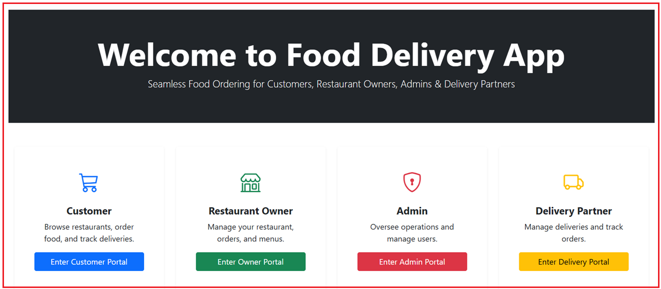

**Customer Home / Landing Page:**

When the user clicks on the Enter Customer Portal link, the following page will be rendered. It introduces the app’s features, displays promotional content, and provides navigation options like login, registration, and food browsing.

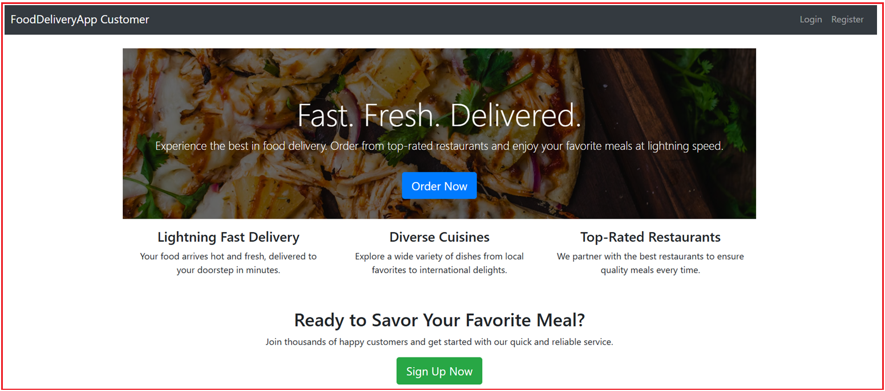

**Registration Page:**

Allows new users to create an account by providing necessary details (e.g., name, email, password) to get started with the service.

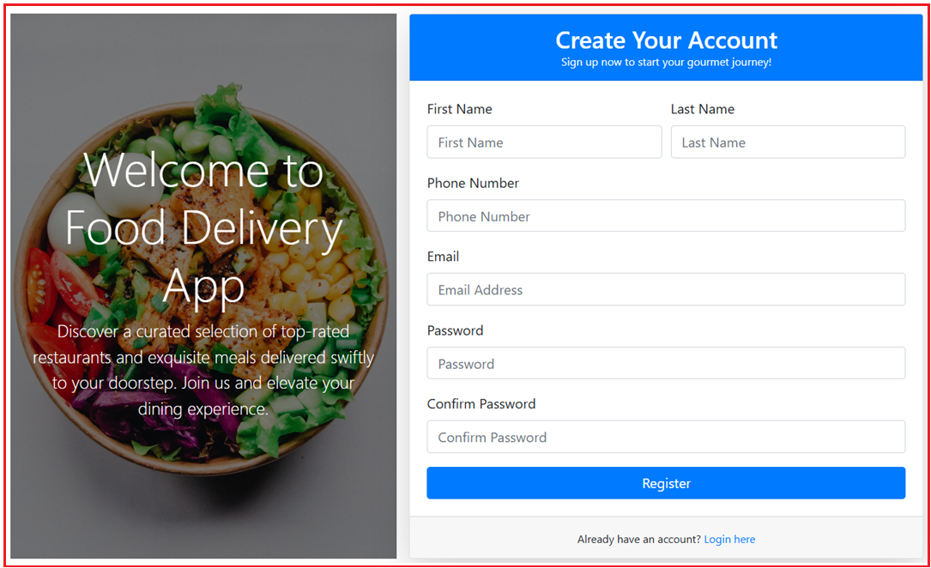

**Customer Welcome Page Part-1**

The first section of a multi-part welcome sequence. It introduces the user to the app’s benefits and overall navigation.

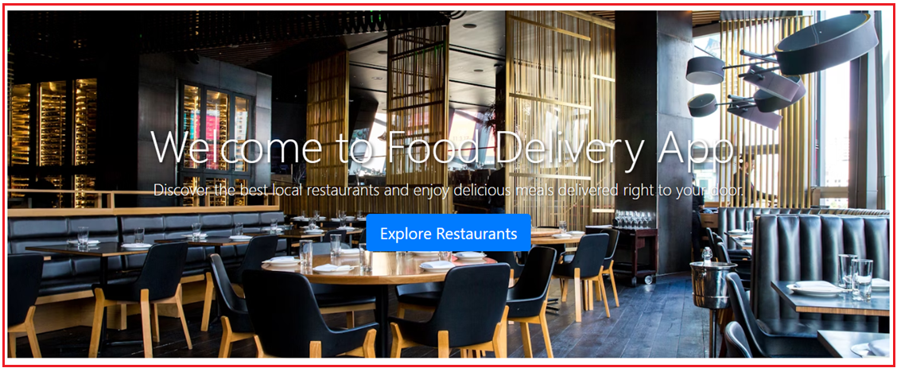

**Customer Welcome Page Part-2**

Continues the onboarding process by highlighting additional features, explaining how to order food, or guiding users through app functionalities.

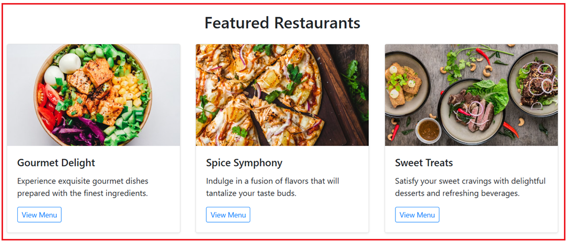

**Customer Welcome Page Part-3**

Concludes the welcome sequence with final instructions or tips on how to best use the app, possibly including any initial incentives or offers.

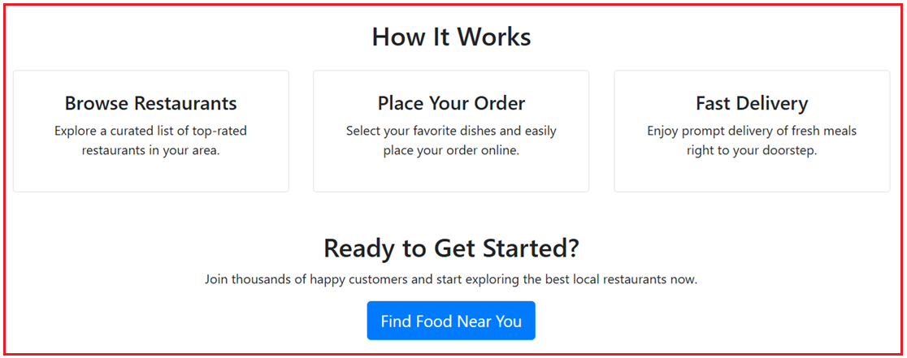

**Customer Registration Successful Email:**

Automatically sent after a successful sign-up. It confirms registration, welcomes the new customer, and might include links to get started or verify the account.

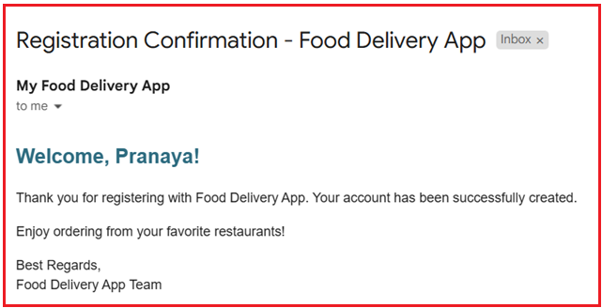

**Login Page:**

Provides returning users with a secure place to enter their credentials and access their account.

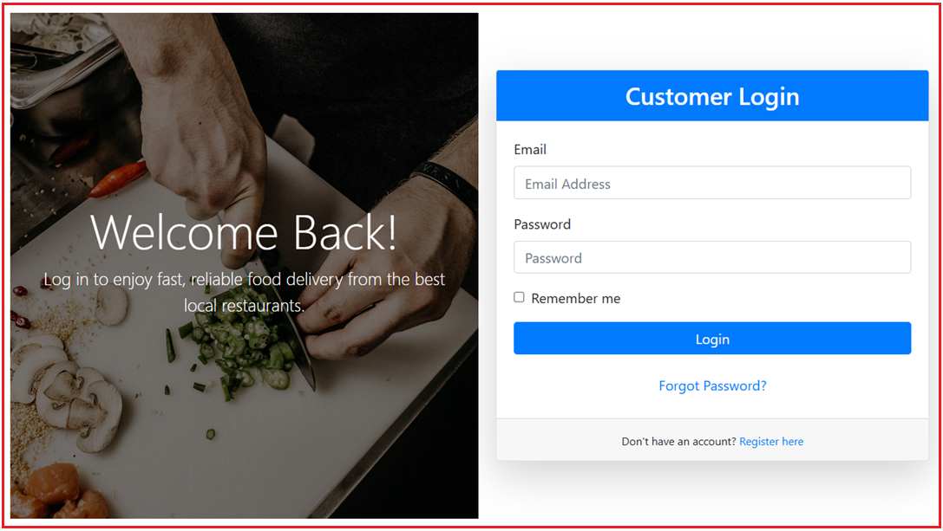

**Customer Food Search Page (Will be enhanced Later):**

Enables customers to search for food items or restaurants. Although it may have basic functionality at first, future enhancements are planned to improve the search experience.

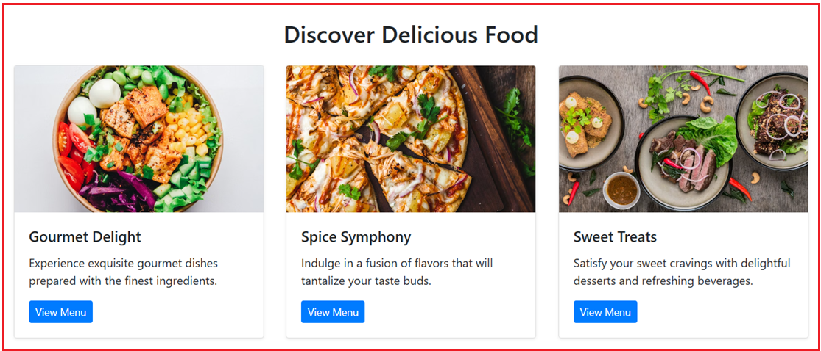

**Change Password Page:**

Let’s users update their password when needed, typically by verifying current credentials and entering a new password.

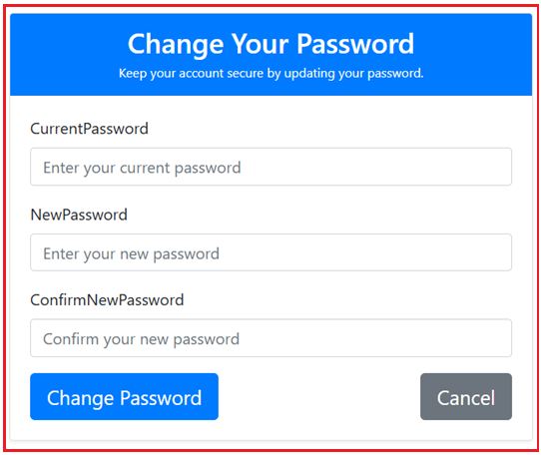

**Password Changed Successful Confirmation Page:**

Displays a confirmation message after a user successfully changes their password, ensuring they know the process completed correctly.

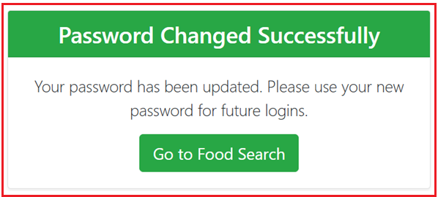

**Change Password Email:**

A notification sent to the user’s email confirming that their password has been updated, adding an extra layer of security by alerting them to changes.

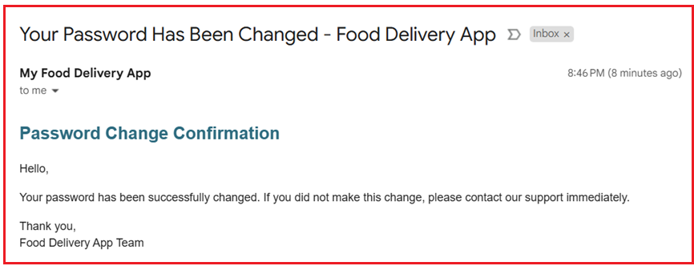

**Customer My Account Page:**

Acts as the central hub where customers can view and manage their personal information, order history, and preferences.

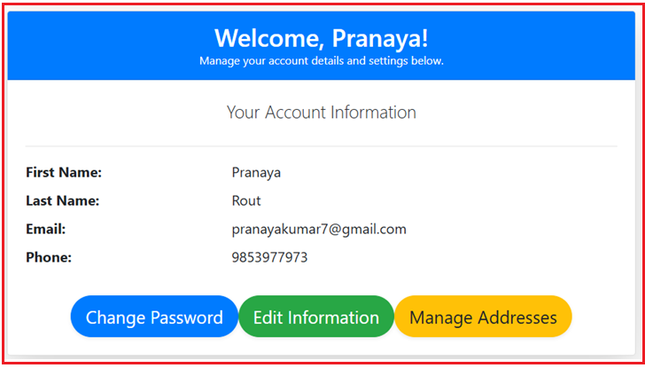

**Customer Update Profile Page:**

Allows users to update their personal details such as name, contact information, and profile picture to keep their account current.

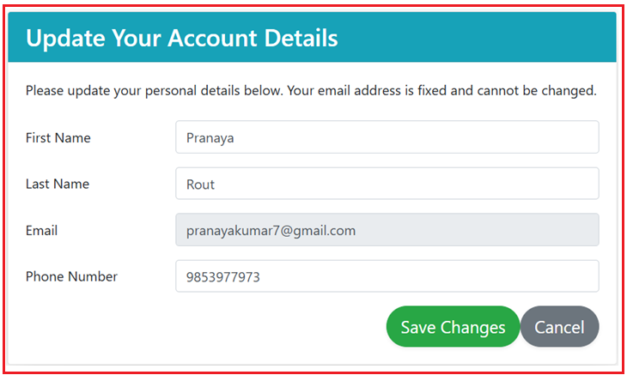

**Customer Manage Address Page:**

Provides an interface for users to view, add, or edit saved delivery addresses to streamline the ordering process.

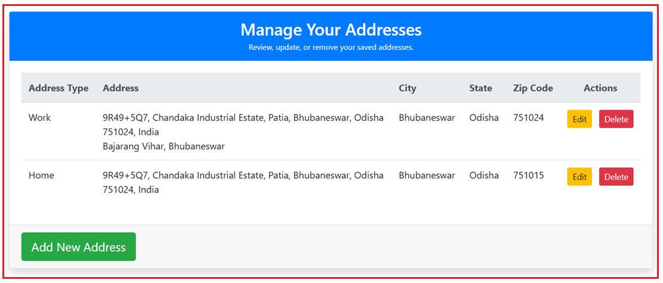

**Add Address Page:**

A dedicated form where customers can input new address details to be saved for future deliveries.

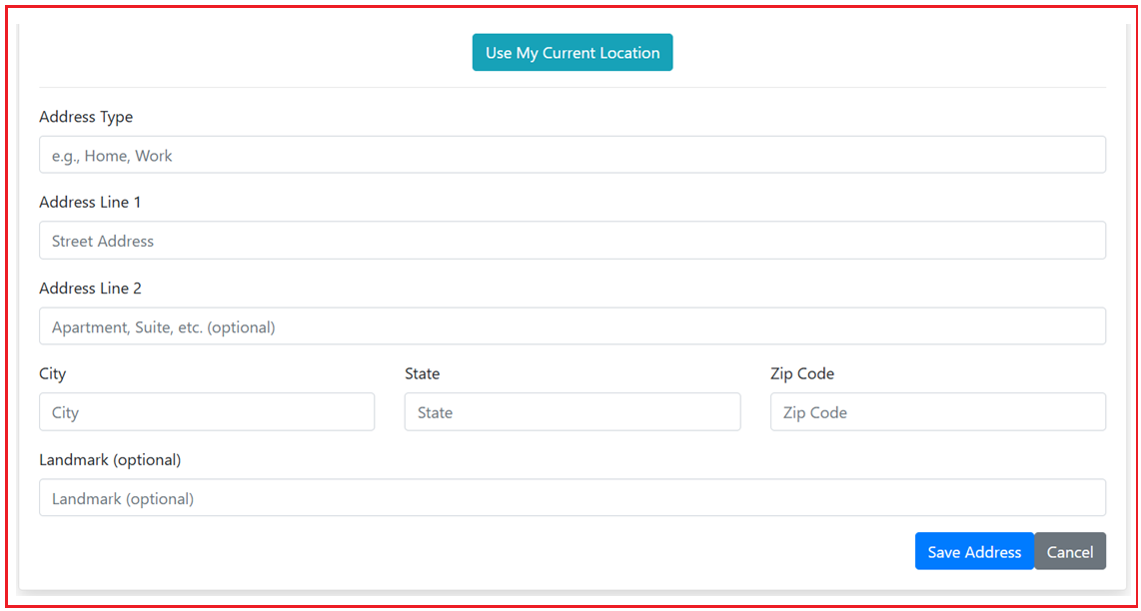

**Update Address Page:**

Enables users to modify details of an existing address if there are changes or corrections needed.

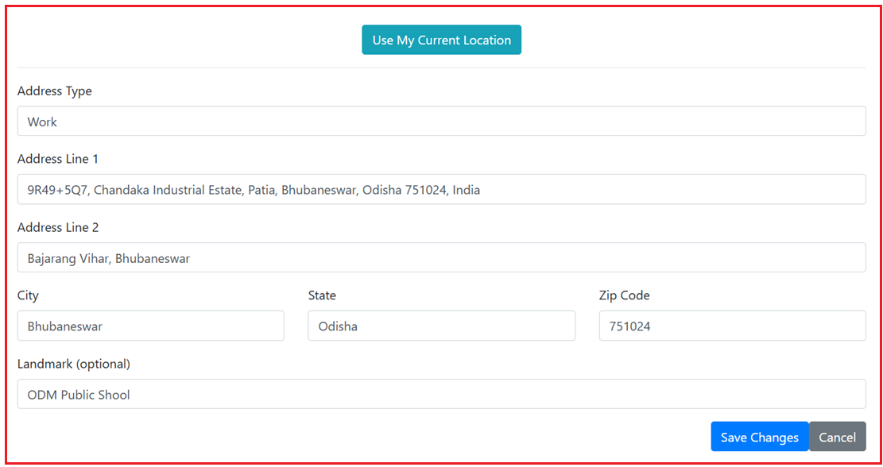

**Forgot Password Page:**

Offers a way for users to initiate a password reset by entering their registered email when they cannot remember their current password.

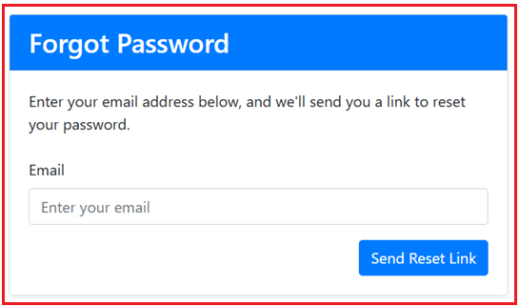

**Forgot Password Confirmation Page:**

Displays a confirmation that a password reset request has been received and that an email has been sent with further instructions.

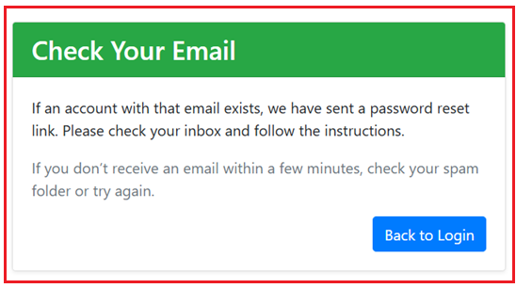

**Reset Password Email Link:**

The email sent to the user containing a secure link. This link directs them to a page where they can safely create a new password.

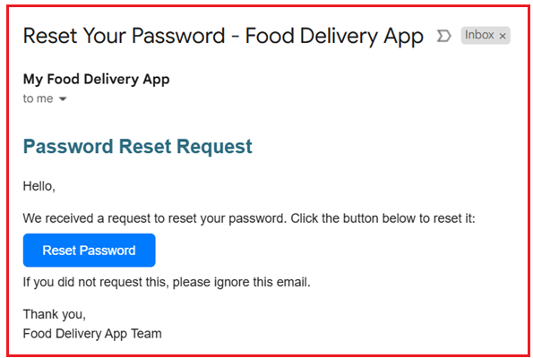

**Reset Password Page:**

The landing page accessed via the email link where the user can enter and confirm a new password.

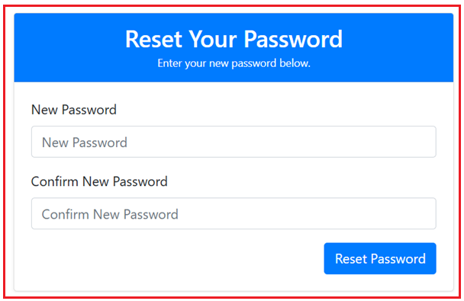

**Password Reset Successful Page:**

Confirms to the user that their new password has been set successfully and that they can now log in using it.

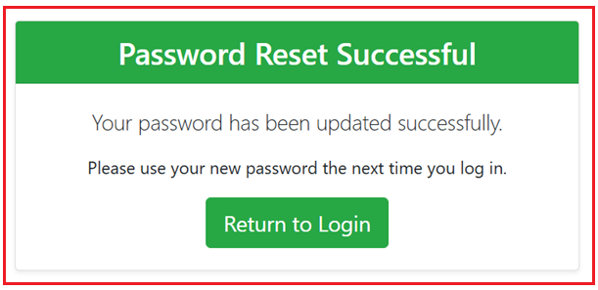

**Password Reset Confirmation**

A final confirmation page that may include additional instructions or a prompt to return to the login page after the reset process is complete.

